**Migration.**  (https://metlifeprod.service-now.com/)

* A Change ticket number will be provided to us.
* Frist we need to create tasks that we need to perform on the production environment regarding the migration of code with respect to the Change ticket number provided.

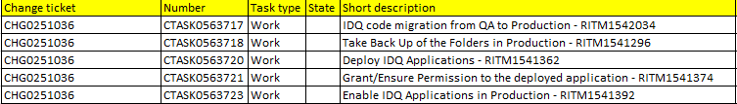

* Now we need to generate respective RITM for each task provided.
  1. For IDQ code migration task from QA to production, we raise a RITM of request type: “Informatica Objects Migrations”.

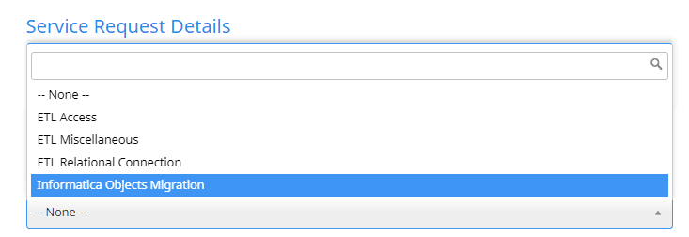

* + Make a request for: “Others”

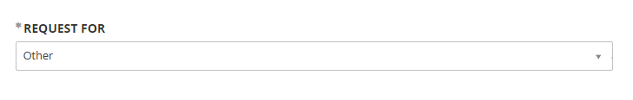

* + In the details Sections

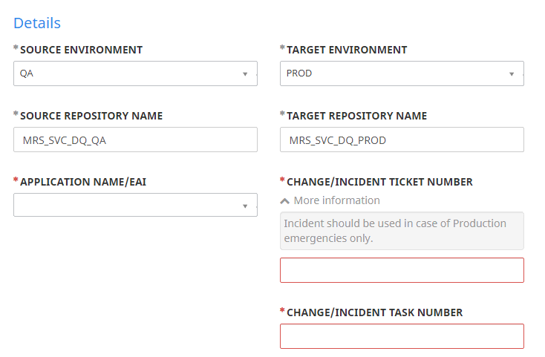

Use the Change Ticket number provided, and for the Change task number use the task number created during the creation of the individual task.

* + For Business reason refer to previous RITM tickets and change accordingly.
  1. For rest of the tasks we raise RITM of request type: “ETL Miscellaneous”.

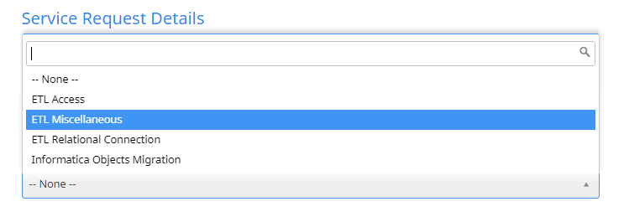

* + Rest of the steps are same as above.
* After creation of RITM’s paste the Respective RITM of the tasks in the comment section of the individual task.
* For reference, we can use a previous change ticket number and we can ask onshore to provide for such.